STATISITCAL GEOGRAPHY
Statistics may be defined as a science of collecting, classifying and using numerical facts. Statistics deals with a collection of numerical information known as data. The data collected convey a lot of information that may be difficult to interpret. In statistics it is easy to interpret and analyze data so that it is easy to draw conclusions.
They are methods of presenting geographical information using tables, graphs, charts and maps. The geographical information may be on number of tourists in a country, percentages of foreign exchange earnings from selected crops, population growth rates or even the movement of people from one area to another.
Reasons for studying statistical geography
- For planning purposes. Statistical information is needed for effective planning. For example population data is needed to plan for the provision of public services.
- To predict the future trends. Statistics can be used to predict the future trends or patterns of phenomenon. For example climate information shows the trends in form of drought or floods. Hence it is important in prediction of future trends of weather and climate.
- To show changes through time. Statistics can be used to show changes over time. For example how the population has been changing for the past five years.
- To make comparison between geographical phenomenon. It is possible to compare the information of one area or country with that of another to determine the differences in growth rate or differences in geographical conditions.
- To establish geographical relationships. Statistics can be used to show relationships between various geographical phenomena. For example we can show whether a relationship exists between vegetation types and climate.
- To confirm the accuracy of measurement; statistical values give exact values of the phenomenon for example, exact and accurate amount of rainfall are recorded to determine the type of climate in the area.
- Illustrates relationship between 2 or more varying quantities e.g. beans production and acreage under cultivation.
- Summarises geographical information which saves time and space. Diagrams and graphs hold huge information in accurate way.
- To equip learners with various skills such as analytical skills, interpretation and presentation of geographical data.
STATISTICAL METHODS
The methods may include the following:
- Line graphs
- Bar graphs
- Circular graphs
- Pie charts
- Rectangular graphs
- Divided circles
- Statistical maps
LINE GRAPHS
This is a method of presenting geographical information using lines. There are different types of line graphs drawn to represent the information. They include:
- Simple line graph
- Comparative line graph/multiple line graph
- Compound/cumulative line graph
SIMPLE LINE GRAPH
This is where lines are drawn to present information. Simple lines are drawn following variables on horizontal and vertical axis.
Construction procedures
- Determine appropriate scale depending on figures given in the table and the size of paper
- Draw vertical and horizontal axis
- Label independent variable on horizontal axis e.g years or countries etc. Independent variables are value whose changes directly influences dependent variables
- Label dependent variables on vertical axis e.g price, percentage or degrees etc. Dependent variables are values area directly influenced by a change in the independent variables.
- The vertical axis should start from zero
- Plot the values using dots
- Join the dots using a straight line
- Lines should not touch the vertical axis
- Indicate title and scale on your graph
Example one; the table blow shows the price of cloves in Tanzania from 1995 to 2002
Years | Price (TZ shillings/kg)
1995 | 2550
1996 | 2600
1997 | 7500
1998 | 30000
1999 | 35000
2000 | 70000
2001 | 31000
Source; North Sulawesi province trade and industry affairs 2001
- Draw a line graph to represent the information in the table
- State merits and demerits of the method

Merits of line graph
- They are simple to draw or construct.
- When neatly drawn, they provide a good visual impression.
- They are easy to interpret.
- Less time is needed to construct them.
- Simple errors or error free because of the simplicity nature of the methods.
- Simple calculations are involved.
- They have a multi-purpose service. For example, they are used in representing several geographical aspects such as the trend of crop production, variation in temperature, minerals, etc.
Disadvantages of line graph
- There is no accurate interpretation because of some points are plotted basing on estimation of values.
- There are difficulties in determining the appropriate scale especially when large figures or values are used.
- The curve graphs are less accurate in comparison to simple line graphs.
- It is not easy to use the simple line and curve graphs to compare various categories of data.
- Changing scale of either axes, can greatly change the visual impression of the graph.
- Have limited implication. They are only used while dealing with continuous data

Example two: the table below shows number of fishermen in East Africa 2005
Country | Percentage of fishermen
Uganda | 27%
Kenya | 27%
Tanzania | 43%
Source; world resources institute
- Draw a line graph to represent the information in the table above

Difference between line graph and curve graph
The procedures of drawing line graph and curve graph are the same.
The difference between the two types of graphs is that for the line graphs, dots are joined using straight lines while for curve graph there are no dots are joined using smooth curves
Example: the table below shows temperature Variations at a station B
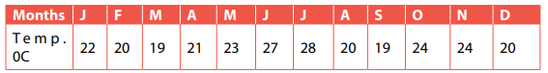
Draw a curve and bar graph to represent the information in the table
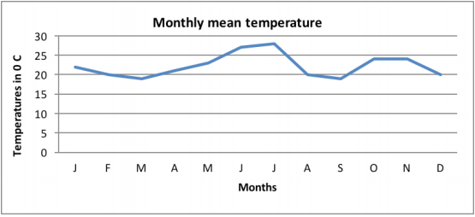
GROUP/COMPARATIVE LINE GRAPH (MULTIPLE LINE GRAPHS)
This is a method of presenting data using grouped lines. Lines are drawn super imposed on each other. This form of statistical method is used to portray more than one dependent variable. It uses several lines of which each represents a given specific variable of individual item.
Construction procedures
- Determine appropriate scale depending on the values given in the table
- Draw horizontal and vertical axis
- Plot the points on the axis starting with the smallest values. Use the dots to mark the points
- Joint the points or dots of each value using straight lines
- Lines should not cross each other for easy comparison
- For comparison and interpretation purposes, lines can be differentiated using colors or different styles with their names labeled
- Indicate title, key and scale on the graph
Example one
The table below shows Uganda horticultural export trends (000tonnes) 2003-2004)
Crops | 2003 | 2004
Legumes | 5235 | 8968
Fruits | 436 | 1769
Vegetables | 2129 | 1907
Source; Uganda export strategy (2008-2012)
Draw a comparative line graph to show the information in the table

Example two: The table below shows the employment and contribution of tourism (000) in Kenya from 2004 to 2005
Employment | 2000 | 2001 | 2002 | 2003 | 2004 | 2005
Modern Sector Employment (MSE) | 1676.8 | 1677.1 | 1699.7 | 1727.6 | 1763 | 1807.5
Wage Employment (W.E) | 155.3 | 156.9 | 157.5 | 162.7 | 168 | 175.7
Source: Kenya central bureau of statistics
- Draw a comparative line graph to show the information in the table

Advantages of comparative line graphs
- Gives good visual impression when well labeled
- Can accommodate variety of item
- Easy to interpret when drawn on good scale
Advantages of comparative line graphs
- Difficult to determine scale when figures are too large
- Require a lot of time to draw and complete
- Occupy large space

Example two
Mineral production in Uganda (2004-2008)
 | Quantity of minerals (Toones)
Minerals | 2004 | 2005 | 2006 | 2007 | 2008
Cobalt | 459,000 | 638,000 | 335,000 | 404,000 | 311,000
Cypsum | 18,000 | 285,000 | 93,000 | 121,000 | 252,000
wolfram | 80,000 | 19,000 | 23,000 | 36,000 | 102,000
Adapted: NEMA 2000/7 state of the environment for Uganda UNP the World Bank.
- Draw a group line graph to show the trend in mineral production between 2004- 2008
- State merits and the demerits of the method.

Advantages of comparative line graphs
- Gives good visual impression when well labeled
- Can accommodate variety of item
- Easy to interpret when drawn on good scale

Advantages of comparative line graphs
- Difficult to determine scale when figures are too large
- Require a lot of time to draw and complete
- Occupy large space

COMPOUND/CUMULATIVE LINE GRAPH
This is a method of presenting data using cumulated values. It is usually used to present information that has accumulated over time; for example accumulated export earnings for different years, number of tourists over years.
Construction procedures
- Determine cumulative values. This is done by adding values accumulated over time and it can easily be done using cumulative tables.
- Determine appropriate scale depending on the accumulated values
- Draw vertical and horizontal axis
- Plot the values using dots or points
- Joint the points by drawing lines above each other to create segments
- Shade segments differently for comparison purposes
- Lines should touch the vertical axis
- The segments should be named or labeled for easy interpretation
Example one: The table below shows forest products raw materials production in the USA in millions of dollars (1965 to 1969)
Year | Sawn logs | Pulpwood | Others
1965 | 1785 | 667 | 784
1966 | 1777 | 693 | 688
1967 | 1687 | 693 | 725
1968 | 1771 | 733 | 744
1969 | 1731 | 781 | 698

Cumulative values
Years | Sawn logs | Pulpwood | Others
1965 | 1785 | + 667 = 2452 | + 784 = 3236
1966 | 1777 | +693 = 2470 | +688 = 3158
1967 | 1687 | +693 = 2380 | +725 = 3105
1968 | 1771 | +733 = 2504 | +744 = 3248
1969 | 1731 | +781 = 2512 | +698 =3210
Compound/cumulative line graph shows forest products raw materials production in the USA in millions of dollars (1965 to 1969)

Advantages of compound/cumulative line graph
- Good for comparative purposes since they involve many items
- Can accommodate various items on the same graph
- Gives good visual impression when well plotted and labeled
- Have multiple purposes because they accommodate many items
- Easy to interpret when well-drawn and on good scale
Disadvantages of compound/cumulative line graph
- They are difficult to determine appropriate scale because of many items
- Involves a lot of calculations to determine accumulative values
- Occupy a lot of space
- Difficult to interpret because they involve many items.
Table below shows copper production in selected states of USA in 000 of metric tones
States | 1970 | 1975 | 1976 | 1977
Arizona | 833 | 788 | 929 | 838
New Mexico | 151 | 132 | 156 | 150
Other states | 200 | 171 | 122 | 122
Total | 1184 | 1091 | 1207 | 1110
- Calculate the percentage of copper production of each state for each year
- Draw a cumulative/compound line graphs to show the percentage of copper production in selected states of USA
Solution
1970 1975 1976 1977
Arizona = 833 x 100% 788 x 100% 929 x 100% 838 x 100%
1184 1091 1207 1110
= 70% =72% =77% =75%

New Mexico = 151 x 100% 132 x 100% 156 x 100% 150 x 100%
1184 1091 1207 1110
= 13% =12% =13% =14%

Others = 200 x 100% 171 x 100% 122 x 100% 122 x 100%
1184 1091 1207 1110
=17% =16% =10% =11%

Cumulative table
States | 1970 | 1975 | 1976 | 1977
Arizona | 70 | 72 | 77 | 75
New Mexico | +13=83 | +12=84 | +13=90 | +14=89
Other states | +17=100 | +16=100 | +10=100 | +11=100

Cumulative/compound line graphs to show the percentage of copper production in selected states of USA from 1970 to 1977

DIVERGENCE LINE GRAPH
This is a method that presents information that fluctuates overtime. Data that tends to increase or decrease overtime is presented using PLUS or positive and MINUS or negative respectively.
Constructive procedures
- Obtain average value of the figures given. This is done by getting the sum of the figures and divide by the number of units.
- Subtract the average value from each figure given. This help to obtain positive and negative values which help to determine fluctuations
- Draw two vertical parallel lines separated by enough space. The space between the two lines depends on the variables to plot on the horizontal axis.
- Determine the central point of the two vertical lines and draw a horizontal line joining them. This horizontal line is marked 0.
- Determine the appropriate scale depending on the positive and negative values obtained
- Plot the positive values above the 0 line and negative values below the 0 lines.
- Draw another horizontal line at the bottom of the two vertical lines. This is drawn at the end of maximum negative values. On this line, independent variables are plotted e.g years
- Plot the values on the graph and join the points staring with the first point up to the last point.

Example: The table below show total fish catch from Ugandans water bodies from 2004- 2009
Year | Fish catch (tones)
2004 | 434000
2005 | 411800
2006 | 362200
2007 | 369300
2008 | 364800
2009 | 366600
Source; 2000-2010 statistical abstract. Uganda Bureau of Statistics (UBOS 2006)
- Draw a divergence line graph to represent the information in the table above.
- Outline the advantages and disadvantages of using the statistical method in a above

Average value = 434,000 + 411,800 + 362,200 + 369,300 + 364,800 + 366,600
6

= 2,308,700
6

= 384,783

434,000 - 384,783 = 49,217
411,800 - 384,783 = 27,017
362,200 - 384,783 = -22,583
369,300 - 384,783 = -15,483
364,800 - 384,783 = -19,983
366,600 - 384,783 = -18,183
Years | Divergence Values
2004 | 49,217
2005 | 27,017
2006 | -22,583
2007 | -15,483
2008 | -19,983
2009 | -18,183

Divergence line graph showing total fish catch from Ugandans water bodies from 2004- 2009

Example: The table below shows tourist arrival in Kenya from 2000 to 2005
Year | 2000 | 2001 | 2002 | 2003 | 2004 | 2005
Tourist arrival 000 | 1036.7 | 993.6 | 1001.3 | 1146.1 | 1358.1 | 1476.0
Source; central bureau of statistics
Average value = 1,036.7 + 993.6 + 1,001.3 + 1,146.1 + 1,358.1 + 1,476.0
6
= 7011.8
6

= 1,168.3

1,036.7 –1,168.3 = -131.6
993.6 –1,168.3 = -174.7
1,001.3 –1,168.3 = -167
1,146.1 –1,168.3 = -22.2
1,358.1–1,168.3 = 189.8
1,476.0 –1,168.3 = 307.7
Years | 2000 | 2001 | 2002 | 2003 | 2004 | 2005
Tourist | -131.6 | -174.7 | -167 | -22.2 | 189.8 | 307.7
Divergence line graph showing tourist arrival in Kenya from 2000 to 2005

Estimates of forest cover in Uganda from 1920 to 1990
Year | 1920 | 1940 | 1960 | 1980 | 1990
Forest cover (km²) | 23,500 | 22,000 | 10,000 | 7, 500 | 7,000
Average value = 23,500 + 22,000 + 10,000 + 7500 + 7,000
5

= 70,000
5

= 14,000

23,000 – 14,000 = 9,000
22,000 – 14,000 = 8,000
10,000 – 14,000 = 4,000
7,500 – 14,000 = -6,500
7,000 – 14,000 = - 7,000
Years | 1920 | 1940 | 1960 | 1980 | 1990
Forest cover | 9,000 | 8,000 | 4,000 | -6,500 | -7,000

Divergence line graph showing the estimates land under forest cover in Uganda from 1920 to 1990

Advantages of divergence line graph
- Easy to draw because it requires joining points using simple lines
- Easy to interpret when drawn on appropriate scale
- Gives a good visual impression
- Occupies less space
- Good for comparison over time because it shows variation in production over long time
Disadvantages of divergence line graph
- Involves a lot of calculation making it tiresome
- Difficult to draw when the values are too large
- Have limited application
- Difficult to interpret especially the negative values
BAR GRAPHS
These are methods of presenting information using bars diagrams. There are different types of bar graphs i.e simple bar graph, group/comparative bar graph/multiple bar graph, cumulative/compound/ divided bar graphs and divergence bar graphs.
SIMPLE BAR GRAPHS
This is a method where information is represented using either horizontal or vertical bars. The bars are drawn to represent one item and therefore they are uniform in width but different in height.
Construction procedures
- Determine appropriate scale depending on the values given
- Draw vertical and horizontal axis. The vertical axis represents dependent variables e.g percentages, volume, numbers etc. The horizontal scale represent independent variables like years, month etc
- Plot the values on the axis using bars following the stated scale; all bars should start from zero.
- Bars should be separated by a constant space.
- The height of bars depends on the variables they are representing.
- Bars should be shaded uniformly
- Bars should be of the same width
- The graph should have a title, scale and key
Example 1: Table showing percentages of fisheries export from east African countries in 2005
Country | Percentage of fish export
Uganda | 27
Kenya | 19
Tanzania | 57
Source; world resources institute

Example 2; the table shows tourists arrivals in Uganda from 1980 to 2003
Years | 1980 | 1981 | 1982 | 1983 | 1984 | 2000 | 2001 | 2003
Arrival(000 | 02 | 04 | 09 | 13 | 152 | 210 | 250 | 200
Sources; Uganda tourist board
- Draw a bar graph to represent the information in the table above
- Outline the advantages and disadvantages of the method used above
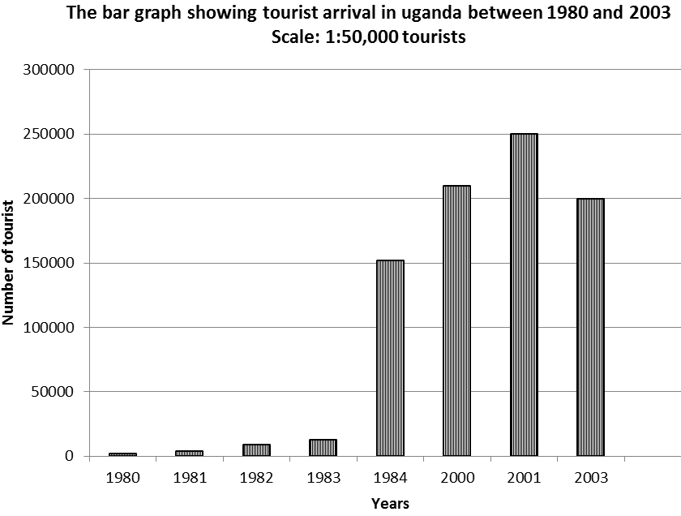
GROUP/COMPARATIVE/ MULTIPLE BAR GRAPHS
This is a method of representing information using grouped bars. The items are represented with a group of bars drawn with the aim of easy comparison.
Construction procedures
- Determine appropriate scale depending on the values provided
- Draw vertical and horizontal axis
- Horizontal axis presents independent variables while vertical axis presents dependent variables like percentage, production values, population etc.
- Plot the values and draw bars of each independent variable
- Bars of each independent variable e.g each year should touch each other to form a group.
- Groups of bars should be separated by constant space
- Bars should be of the same width but different height (height depends on the variable they are representing).
- Bars of similar item in each group should be shaded in the same way for easy interpretation
- The graph should have title key, scale and should neat.

Example: The table below shows the population of selected African countries between 1987 and 1996
Countries | Population in million (1987) | Population in million (1996)
Liberia | 2.30 | 2.82
Nigeria | 88.27 | 114.40
DRC | 33.87. | 45.34
- Draw a group bar graph to show the information contained in the table above
- Calculate the percentage increase in the population of each of the selected country between 1987 and 1996
Solutions
Group bar graph showing the population of selected African countries between 1987 and 1996

Liberia = 2820000 - 2300000 x 100
2300000
= 520000 x 100
2300000
=22.6%
Nigeria =114400000 – 88270000 x 100
88270000
26130000 x 100
88270000
= 29.6%
DRC = 45340000 – 33870000 x 100
33870000
=34%
Study the table below showing annual copper production for selected countries between 1980 and 1990 (000 metric) tones
Country | 1980 | 1985 | 1990
Chile | 1063 | 1360 | 1628
China | 115 | 185 | 375
USA | 1181 | 1105 | 1498
Zambia | 596 | 453 | 445
Adapted; world resource (1996/7, 1998/9 series); A guide to the global environment

A comparative bar graph showing annual copper production for selected countries between 1980 and 1990 (000 metric) tones

Advantages of comparative bar graph
- Good for comparative purposes since they involve many items
- Can accommodate various items on the same graph
- Gives good visual impression when well plotted and labeled
- Have multiple purposes because they accommodate many items
- Easy to interpret when well-drawn and on good scale
Disadvantages of comparative bar graph
- They are difficult to determine appropriate scale because of many items
- Involves a lot of calculations to determine accumulative values
- Occupy a lot of space
- Difficult to interpret because they involve many items.
COMPOUND/CUMULATIVE BAR GRAPH
This is a method where information is represented with supper imposed bars. Different items of similar independent variables like a year are represented on the same bar using cumulative values.
Construction procedures
- Determine cumulative values using the figures given in the table
- Determine appropriate scale using cumulative values obtained
- Draw horizontal and vertical axis
- Plot independent variable on horizontal axis e.g. years and dependent variables on the vertical axis e.g. percentages
- Plot the values of each item and each variable. Start with the largest value
- Super impose the values of different items to create segments of each bar
- Segments of similar items in each bar should be shaded in similar way for easy Interpretation.
- If values are in percentages, bars should be of the same height and when they are in absolute values bars should be of different height.
- The graph should have title, scale, key and should be neat.
Example
Study the table showing fuel wood consumption (in 000 tones) in Uganda between 2009 and 2012
SECTION | 2009 | 2010 | 2011 | 2012
Household | 21,905 | 22,692 | 23,507 | 24,327
Commercial | 3,181 | 3,256 | 3,334 | 3,410
Industrial | 2,080 | 2,126 | 2,172 | 2,217
Draw a cumulative bar graph to represent the information given in the table

Cumulative values/table
Sections | 2009 | 2010 | 2011 | 2012
Household | 21,905 | 22,692 | 23,507 | 24,327
Commercial | +3,181= 25,086 | +3,256=25,948 | +3,334=26,841 | +3,410=27,737
Industrial | +2,080=27,166 | +2,126=28,074 | +2,172=29,013 | +2,217=29,954

Cumulative bar graph showing fuel wood consumption (in 000 tones) in Uganda between 2009 and 2012

The table below shows the Canada’s mineral production by class in million dollars from 1965 to 1976
Years | Metals | Non-metals | Fossil fuel | Structured minerals | Total
1965 | 1,908 | 327 | 1,045 | 434 | 3,714
1970 | 3,073 | 481 | 1,718 | 450 | 5,722
1975 | 4,794 | 939 | 6,644 | 960 | 13,337
1976 | 5,241 | 1,143 | 7,993 | 1,016 | 15,393
- Calculate the percentages of each mineral in each year
- Draw cumulative/compound bar graph to show percentage of Canada’s mineral production from 1965 to 1976
Solutions
Metals Non-metals Fossil fuel Structured minerals
1965 = 1,908 x 100% 327 x 100% 1,045 x 100% 434 x 100%
3,714 3,714 3,714 3,714
= 51% =09% =28% =12%

1970 = 3,073 x 100% 481 x 100% 1,718 x 100% 450 x 100%
5,722 5,722 5,722 5,722
= 54% =08% =30% =08%
1975 = 4,794 x 100% 939 x 100% 6,644 x 100% 960 x 100%
13,337 13,337 13,337 13,337
= 36% = 07% = 50% = 07%

1976 = 5,241 x 100% 1,143 x 100% 7,993 x 100% 1.016 x 100%
15,393 15,393 15,393 15,393
= 34% = 07% = 52% = 07%

Cumulative table
Year | Metals | Non-metals | Fossil fuel | Structured minerals
1965 | 51 | +09=60 | +28=88 | +12=100
1970 | 54 | +08=62 | +30=92 | +08=100
1975 | 36 | +07=43 | +50=93 | +07=100
1976 | 34 | +07=41 | +52=93 | +07=100
A cumulative/compound bar graph to showing the percentage of Canada’s mineral production from 1965 to 1976

Advantages of compound/cumulative bar graph
- Good for comparative purposes since they involve many items
- Can accommodate various items on the same graph
- Gives good visual impression when well plotted and shaded
- Have multiple purposes because they accommodate many items
- Easy to interpret when well-drawn on good scale
Disadvantages of compound/cumulative bar graph
- They are difficult to determine appropriate scale because of many items
- Involves a lot of calculations to determine accumulative values
- Occupy a lot of space
- Difficult to interpret because they involve many items.
LINE AND BAR GRAPH (CLIMATE GRAPH)
These are graphs that represent information about elements of weather. The common elements presented are temperatures and rainfall totals of a given area or a station.
Construction procedures
- Choose appropriate scale for rainfall and temperatures
- Draw vertical Axis and horizontal axis.
- In the middle of vertical axis draw another horizontal line. This line is marked 0 and labeled freezing line
- Below the freezing line, plot rainfall scale and above the line plot the temperature scale
- Rainfall is plotted using bar graphs while temperature is plotted using line graph
- The scale of rainfall and temperature should be clearly indicated
- The graph should have a title and should be neat.
Example; climate characteristics of station
Months | J | F | M | A | M | J | J | A | S | O | N | D
Temp | 24 | 25 | 24 | 23 | 22 | 21 | 22 | 22 | 22 | 22 | 23 | 23
Rainfall(mm | 10 | 51 | 89 | 170 | 211 | 145 | 185 | 216 | 170 | 160 | 90 | 50
Draw a climate graph to show the information in the table above

Example 2; climatic characteristics of Songea
Months | J | F | M | A | M | J | J | A | S | O | N | D
Temp | 22 | 23 | 21 | 19 | 19 | 17 | 17 | 18 | 21 | 22 | 23 | 21
Rainfall(mm | 270 | 250 | 200 | 198 | 15 | 05 | 00 | 05 | 10 | 40 | 157 | 182

Advantages of the climate graph
- Easy to draw
- Don’t involve calculation
- Easy to determine scale
- Easy to interpret when drawn of scale
- Has many applications
- Accommodates many items especially climatic elements
- Gives good visual impression
Disadvantages of climate graphs
- Difficult to draw because if involves plotting two or more items in the same graph
- Occupies large space because it accommodates many items
- Requires a lot of time to determine scale of two items

DIVERGENCE BAR GRAPHS
This is a method that presents data that tends to increase or decrease overtime. It is presented using positive values or negative values.
Construction procedures
- Obtain average value of the figures given. This is done by getting the sum of the figures and divide by the number of units.
- Subtract the average value from each figure given. This help to obtain positive and negative values which help to determine fluctuations
- Draw two vertical parallel lines separated by enough space. The space between the two lines depends on the variables to plot on the horizontal axis.
- Determine the central point of the two lines and draw a horizontal line joining them. This horizontal line is marked 0.
- Determine the appropriate scale depending on the positive and negative values obtained
- Plot the positive values above the 0 line and negative values below the 0 line.
- Draw another horizontal line at the bottom of the two vertical lines. This is drawn at the end of maximum negative values. On this line, independent variables are plotted e.g years
Example: The foreign income earnings from tourist arrival in Kenya between 2000 and 2003
Year | 2000 | 2001 | 2002 | 2003
Foreign income earnings (Kshs) | 21,533 | 24,239 | 21,734 | 25,765

Average value = 21,533 + 24,239 + 21,734 + 25,765
4

= 93,271
4

= 23,318

21,533 – 23,318 = -1,785
24,239 – 23,318 = 921
21,734 – 23,318 = -1,584
24,765 – 23,318 = 1447

Years | 2000 | 2001 | 2002 | 2003
Foreign income earnings (Kshs) | -1,785 | 921 | -1,584 | 1447

Advantages of divergence bar graph
- Easy to draw because it requires joining points using simple lines
- Easy to interpret when drawn on appropriate scale
- Gives a good visual impression
- Occupies less space
- Good for comparison over time because it shows variation in production over long time
Disadvantages of divergence bar graph
- Involves a lot of calculation making it tiresome
- Difficult to draw when the values are too large
- Have limited application
- Difficult to interpret especially the negative values

CIRCULAR GRAPHS (POLAR GRAPHS)
These are graphs that represent seasons and related activities of a given area. The season could be the growing season or production season in relation to agricultural activities or industrial activities respectively.
Construction procedures
- Draw small circle; the circle should not be too small
- Draw another bigger circle to enclose the small circle
- Draw a vertical line at right angle connecting the big circle to the small circle. On this line rainfall is plotted
- Divide the big circle into twelve segments
- Each segment represents a month and they are named clock wise starting from segment at a right angle as January
- Labeling of the circular graph begins from twelve o’clock which marks the month of January. Thereafter, other months follow, taking the clock wise order up to December.
- Temperature is plotted at the radii below small circle
- Plot points for temperature and join each with a continuous curve.
- Plot rainfall using bars and rainfall scale is libeled on the twelve o’clock line.
- Activities are represented inside the small circle
- Avoid writing words that are upside down or sharply tilted. The writing on the graph should enable the reader not to tilt or turn around the graph.
- Indicate scale, title and be neat
Example I
Table showing agricultural activities through the year and received rainfall at station A
Months | Rainfall | Planting | Harvesting
January | 32 | Land clearing | Land clearing
February | 56 | Sorghum | Wheat
March | 89 | Weeding | -
April | 345 | Beans | -
May | 345 | Millet | -
June | 200 | Millet | -
July | 208 | - | -
August | 312 | Maize | -
September | 213 | - | -
October | 278 | - | -
November | 100 | - | Sorghum
December | 190 | - | -

- Draw a circular graph to show the information in the table
- State the advantages and disadvantages of the methods
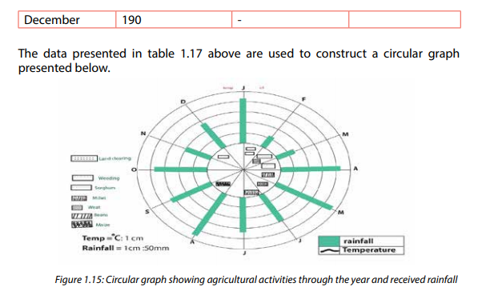
Example II
Farming calendar of small farmers in Sukuma land
Months | Jan |  | Feb | Mar | April |  | May | June | July | Aug | Sep |  | Oct | Nov | Dec
Rainfall (mm) | 71 |  | 72 | 99 | 79 |  | 76 | 43 | 10 | 20 | 30 |  | 15 | 48 | 68
Temp (⁰C) | 25 |  | 25 | 22 | 19 |  | 22 | 25 | 30 | 28 | 25 |  | 22 | 29 | 30
Activities |  | - Crop growing  - Ripening  - Weeding |  |  |  |  |  | Animal rearing  (Rotational grazing) |  |  |  |  |  | Land preparing  Planting crops
 |  |  |  |  |  | Harvesting season

DIVIDED RECTANGLES
This is a method where information is presented using rectangles. There are two types of rectangles:
- Simple divided rectangles
- Compound divided rectangles

SIMPLE DIVIDED RECTANGLES
This is where the data represented alongside their respective values. The rectangle is subdivided to represent the respective values.

Construction procedures
- Determine cumulative values using cumulative table. This helps to determine the totals of the values
- Draw a horizontal axis on which the values and scale are plotted
- Determine appropriate scale which is plotted on the horizontal axis
- On horizontal axis plot the cumulated values. Each value forms its own vertical segment called rectangle.
- Each segment or rectangle is shaded differently since they represent different items. This also helps in interpretation of the graph
- Vertical scale is neglected
- The key may be used to interpret the meaning of the shades/rectangles
- The graph should be neat with a title, key and scale. All segments are of the same height.

Organization of Mwea–Tebere irrigation scheme
Block | Area covered (ha)
Tebere  Thiba  Mwea  Wamumu | 3,000  2,800  3,000  1,300

Cumulative values
Block | Area covered (ha)
Tebere  Thiba  Mea  Wamumu | 3,000  +2,800=5,800  +3,000=8,800  +1,300
Total | 10,100

Divided rectangles showing blocks of land in hectares at Mwea–Tebere irrigation scheme
Tebere Thiba Mea Wamumu
0 2000 4000 6000 8000 10,000 12,000
Area covered (ha)
Scale 1:1000

Scale 1:1000
Percentage of fishermen in east African countries in 2005
Country | Percentage of fishermen
Uganda | 27
Kenya | 27
Tanzania | 46
Total | 100

Cumulative figures
Country | Percentage of fishermen
Uganda | 27
Kenya | +27=54
Tanzania | +46
Total | 100

Divided rectangle showing percentage of fishermen in East African countries in 2005
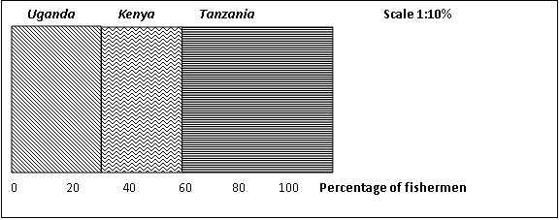
COMPOUND DIVIDED RECTANGLES
This is a method where the information is presented using divided segments of the rectangles.
Construction procedures
- Draw cumulative figures for each item
- Draw vertical and horizontal axis
- Determine appropriate vertical and horizontal scale
- Horizontal axis represents total of all items while vertical axis represents cumulative values of each item. This may be in percentage
- The segments of each item should be shaded for easy interpretation
- The graph should have title, scales, key and neat

Example I
The table below shows how the land is used in country X.
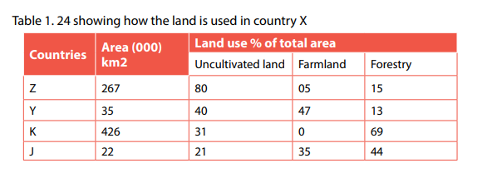
Draw compound divided rectangle to represent the information in the table above

Compound divided rectangles showing land use in country X
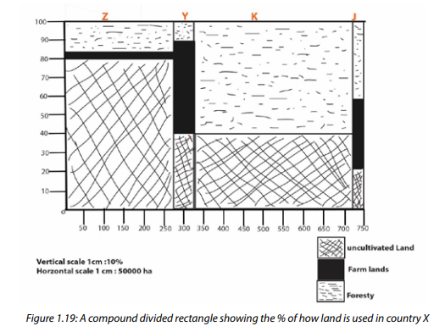

Example II;
The table below shows the share of total area under forest cover by 2005 for country X
Region | Central Forest Reserve(CFR) in Hectare | Local Forest Reserve(LFR) in hectare | Total (hectare)
Central | 303,356 | 1,576 | 304,932
Eastern | 56,479 | 1,531 | 58,010
Northern | 556,825 | 1,447 | 558,272
Western | 356,037 | 431 | 356,468
Total | 1,272,697 | 4,985 | 1,277,682

Cumulative figures
Regions | Central Forest Reserve(CFR) in Hectare | Local Forest Reserve(LFR) in hectare | Total (hectare)
Central | 303,356 | +1,576 = 304,932 | 304,932
Eastern | 56,479 | +1,531 = 58,010 | +58,010=362,942
Northern | 556,825 | +1,447 = 558,272 | +558,272=921,214
Western | 356,037 | +431 = 356,468 | +356,468
Total | 1,272,697 | +4,985 = 1,277,682 | 1,277,682
Compound divided rectangle showing the share of total area under forest cover by 2005 for country X

Exercise
The table shows total area of tea in Kenya (000) hectares
Year | Total | Estate tea | Small holding tea | Other
1965 | 24.5 | 19.3 | 5.1 | 0.1
1968 | 28.8 | 18.0 | 10.8 | 00
1970 | 40.3 | 22.3 | 18.0 | 00
1980 | 51.1 | 25.5 | 25.5 | 0.1
- Calculate the percentage of each area under tea growing for each year
- Draw a cumulative rectangle to represent the percentages of land under tea growing for each year.

POPULATION PYRAMIDS (AGE AND SEX GRAPHS)
This is a method that represents the structure of population of a given country. The characteristics of the population are represented in terms of sex and age compositions. There are simple population pyramid and compound population pyramids.
SIMPLE POPULATION PYRAMIDS
This is where the population structure of a given country is represented for a given period of time usually a year.
Construction procedures
- Draw two vertical lines separated by a space of about 2cm-3cm. It is in this space between the two lines that age groups are plotted. The young group is at the bottom while the old age group is at the top.
- At the bottom of the two vertical lines, draw horizontal lines moving in the opposite direction. It is on these two lines that values are plotted. The values may be in absolute or in percentages.
- Males are usually represented on the left while female on the right.
- Bars are plotted horizontally.
- All axes should be labeled.
- The graph should have title, scale and should be neat

Example
The table shows female and male population figures (demographic data) in thousands ‘000’ of country A.
Age group | Female population (000) | Male population (000)
0 - 4 | 150 | 120
5 - 9 | 150 | 101
10 - 14 | 148 | 98
15 - 19 | 145 | 90
20 - 24 | 140 | 98
25 - 29 | 139 | 98
30 - 34 | 130 | 100
35 - 39 | 129 | 99
40 - 44 | 120 | 80
45 - 49 | 118 | 85
50 - 54 | 110 | 89
55 - 59 | 98 | 50
60 + | 90 | 45

- Draw a population pyramid to portray the information shown in the table.
- State the advantages and advantages of the statistical method.

Advantages of pyramids
- They are easy to interpret when properly on the scale and labeled.
- They give good visual impression
- They represent a variety of demographic information
- They are good for comparison purposes e.g over time and places

Disadvantages of pyramids
- They have limited applications
- Occupy a lot of space especially when it contains a lot of information
- Difficult to interpret when it contain a lot of information
- Requires a lot of time to plot female and male bars

SUPER-IMPOSED/COMPOUND PYRAMID
The steps of constructing a compound pyramid are the same steps of a single pyramid. The difference is that for compound pyramid, the bars are super imposed to show information of the population for various period of time or for different countries.

Example
The table below shows the population per age group in percentage for selected years 2001 and 2002 in country X.
Age group | 2001 |  | 2002
 | Male | Female | Male | Female
0 – 4 | 23 | 32 | 26 | 43
5 – 9 | 20 | 28 | 24 | 38
10 – 14 | 32 | 29 | 38 | 49
15 – 19 | 30 | 36 | 34 | 45
20 – 24 | 31 | 38 | 36 | 31
25 – 29 | 26 | 29 | 31 | 28
30 – 34 | 23 | 26 | 29 | 39
35 – 39 | 16 | 20 | 24 | 34
40 – 44 | 13 | 17 | 19 | 27
45 – 49 | 09 | 16 | 15 | 24
50 + | 08 | 12 | 12 | 19
- Draw a super-imposed population pyramid to portray the information in the table

STATISTICAL CHARTS
- Pie charts/ divided circles
- Comparative divided circles
- Combined proportional divided semi circles

PIE CHARTS/ DIVIDED CIRCLES
This is a method where information is represented using circles or pie charts. The information is converted into degrees to construct angles of specific items or values.
Construction procedures
- Convert the values of each item into degrees using the formula below; Value x 360⁰
Total
- Draw a circle of convenient size. Avoid too small or too large circles
- Draw radii at 12 o’clock position of the circle. This line should slop up to the centre of the circle.
- Using protractor measure the angles of each value starting from 12 o’clock.
- The angles should be drawn clock wise starting from 12 o’clock radii.
- Draw each segment of each value or item depending on the angle measured
- Shade the segments differently for easy interpretation
- Write raw data in the chart in each segment or item it represents
- The chart should have a title and key

Example; tourist arrival in East Africa
Country | Number of tourist arrivals
Uganda | 467,729
Kenya | 1,479,000
Tanzania | 612,274
Total | 2,559,003
- Draw a pie chart to represent the information in the table
- State merits and demerits of the method
A pie chart showing tourist arrival in East Africa countries
Solution

Uganda = 467729 x 360⁰
2559003
= 66⁰
Kenya = 1479000 x 360⁰
2559003
= 208⁰

Tanzania = 612274 x 360⁰
2559003
= 86⁰

Advantages of pie charts
Gives good visual impression
Easy to draw
Occupy small space
Easy to interpret when well shaded

Disadvantages of pie charts
- Involves a lot of calculations to convert into degrees
- Difficult to draw especially constructing angles
- Consumes a lot of time since it involves calculations

COMPARATIVE DIVIDED CIRCLES OR PROPORTIONAL DIVIDED CIRCLES
These are drawn to compare information from different areas, countries or years. The charts or circles are drawn in proportion to the total of the information they are representing.

Construction procedures
- Obtain the totals of each group of items. This is done when totals are not given
- Convert the values of each item in each group into degrees
- To determine the size of each circle, the radius is determined using the formula that
R= √ A
π
Where A is total of the values.
The answer obtained determines the radius and the size of each circle
- Draw the circle of each total value using the radius determined
- Circles should be drawn close to each other for comparison purposes
- Draw angles of each item in each circle to create segments as it was done under divided circles/pie charts.
- Similar items with similar segments in each circle should be shaded in the same way for easy interpretation.
- Use key for interpretation
- The radius of each circle should be stated

Example; percentage railway and pipeline network in east African countries in 2004
Country | Railway network | Oil& gas pipeline
Uganda | 14 | 00
Kenya | 45 | 40
Tanzania | 41 | 60
Total | 100 | 100
Source: East African community secretariat
Total: Railway = 100% oil and gas pipeline = 100%
Railway
Uganda = ${14}/{100}$x 360⁰
= 50 ⁰

Kenya =${ 45}/{100}$x 360⁰

Oil and gas pipeline
R= A
π
R= 100
π
R= 100
31.8
=3.18

Radius of circles
Railway network
R= A
π
R= 100
π
R= 100
31.8
=3.18

= 162 ⁰
Tanzania =${41}/{100}$x 360⁰
= 148 ⁰
Oil and gas
Uganda =${00}/{100}$x 360⁰
= 00
Kenya =${40}/{100}$x 360⁰
= 144
Tanzania =${60}/{100}$x 360⁰
= 216

Since the figures are too large we can multiply with 10 e.g 31.8 x 10 = 3.1cm
Since the totals are of the same, the circles are expected to be of the same size

Proportional divided circles showing percentage of railway and pipeline network in east African countries in 2004

R = 3.1CM R = 3.1CM

Uganda’s horticultural export for selected crops in (000 tones) 2003- 2004
Crops | 2003 | 2004
Legumes | 5235 | 8968
Fruits | 436 | 1769
Vegetables | 2129 | 1907
Total | 7800 | 12644

Draw a proposal divided circles to present the information in the table above
Solutions
2003
2004
Legumes = 8968 x 360
12644
= 255⁰

Fruits = 81769 x 360
12644
= 50⁰
Vegetables = 1907 x 360
12644
= 54⁰

Legumes = 5235 x 360
7800
= 242⁰

Fruits = 436 x 360
7800
= 20⁰

vegetables = 2129 x 360
7800
= 98⁰

Radius of the circles
2003
2004
R = A
Π
R = 12644
31.9
R = 396
= 396
100
R = 3.9 or 4 cm
R = A
Π
R = 7800
31.8
R= 245
= 245
100
R = 2.45 or 2.5CM
Proportional divided circles showing Uganda’s horticultural export for selected crops in (000 tones) 2003- 2004

R = 2.5CM R = 4 cm

COMBINED PROPORTIONAL DIVIDED SEMI CIRCLES
The charts or semi-circles are drawn in proportion to the total of the information they are representing. They are drawn combined to each other for easy comparison.

Construction procedures
- Obtain the totals of each group of items. This is done when totals are not given
- Convert the values of each item into degrees using a formula; X x 180⁰
Total
- To determine the size of each semi-circle, determined radius using the formula that
R= A
π
Where A is total of the values.
The answer obtained determines the radius and the size of each semi-circle
- Draw a vertical line; determine the central point of the line. On the left side of the line, measure the small radius calculated while on the right side measure the largest radius calculated.
- Draw the semi-circle on each side of the vertical line depending on the radius measured.
- Draw angles of each item in each semi-circle to create segments. Similar items with similar segments in each semi-circle should be shaded in the same way for easy interpretation.
- Use key for interpretation
- The radius of each circler should be stated

Example
The table below shows livestock number for selected animals (208-2009) in Uganda
Livestock | 2008 | 2009
Cattle | 11,409,000 | 14,751,000
Goats | 12,450,000 | 15,823,000
Sheep | 3,410,000 | 5,823,000
Pig | 3,184,000 | 4,280,000
Total | 30,453,000 | 40,677,000

Draw combined proportional divided semi circles to present the information in the table above.
Solutions
Degrees
2009
Cattle = 14,751,000 x 180⁰
40,677,000
= 65⁰

Goat = 15,823,000 x 180⁰
40,677,000
= 70⁰

Sheep = 5,823,000 x 180⁰
40,677,000
= 26⁰

Pig = 4,280,000 x 180⁰
40,677,000
= 19⁰

2008
Cattle = 11,409,000 x 180⁰
30,453,000
= 67⁰

Goat = 12,450,000 x 180⁰
30,453,000
= 74⁰

Sheep = 3,410,000 x 180⁰
30,453,000
= 20⁰

Pig = 3,184,000 x 180⁰
30,453,000
= 19⁰

R = A = 30,453,000
R = A = 40,677,000
Π 31.9

R = 1,275,141 ÷ 1,000,000

R = 1.275 OR 1.3CM

Π 31.9

R = 954,639 ÷ 1,000,000

R = 0.95 OR 1CM

Combined proportional divided semi circles showing livestock number for selected animals (208-2009) in Uganda

The table below shows production of main construction materials in Canada in 000 metric tones
Minerals | 1973 | 1976
Asbestos | 906 | 1,799
Lime | 1,601 | 2,825
Sand and gravels | 156,155 | 247,660
Stones | 58,921 | 109,180
Totals | 217,583 | 361,464

- Draw a combined proportional divided semi circles to show the information in the table above
- State the advantages and disadvantages of the method used
Solutions
1976
Asbestos = 1,799,000 x 180⁰
361,464,000
= 01⁰
Lime = 2,825,000 x 180⁰
361,464,000
= 02⁰
Sand and gravel = 247,660,000 x 180⁰
361,464,000
= 123⁰
Stones = 109,180,000 x 180⁰
361,464,000
= 54⁰

Radius = A = 361,464,000
Π 31.9

Radius = 11,331,160 ÷ 10,000,000
Radius = 1.13
= 1.1cm
1973
Asbestos = 906,000 x 180⁰
217,583,000
= 0.7⁰

Lime = 1,601,000 x 180⁰
217,583,000
= 1.3⁰
Sand and gravel = 156,155,000 x 180⁰
217,583,000
= 129⁰

Stones = 58,921,000 x 180⁰
217,583,000
= 49⁰

Radius = A = 217,583,000
Π 31.9
Radius = 6,820,784 ÷ 10,000,000
Radius = 0.68
= 1cm

STATISTICAL MAPS
There are many maps which are used to present information. Maps used to present statistical information are called qualitative maps. These maps include;
- Dot maps
- Flow maps
- Chlorapleth maps
- Isoline maps

DOT MAPS
These show the distribution of a phenomenon in space by means of dots. Dots are fixed in size and are placed on the map to show the approximate location of the phenomenon. A dot represents actual numbers. They are commonly used to show:
- Human population
- Distribution of crops and livestock
- Distribution of settlement
- Distribution of industries etc
Construction procedures
- Obtain a suitable base map. This should show administrative units of the area.
- Choose a suitable dot value. This show number of units each dot represents on the map. This is done by dividing each value given by the constant unit e.g 1000, 10,000 etc
- Determine the number of dots for each area or region or country given on the map
- Locate the dots with aid of the topographical map. Topographical map shows forested areas, lakes swamps, steep slopes etc. Avoid putting dots in areas they are not supposed to be. E.g. population dots in forests or water bodies are not allowed.
- Mark on the map the positions of all dots lightly in a pencil
- Draw dots in marked positions of correct size, circular and uniform in character
- Complete the map with a title, scale and the key

Example
Hectares of land under coffee and pineapples in selected districts in the mid-western Uganda
District | Coffee (000 ha) | Pineapple (000 ha)
Hoima | 145061 | 1211
Masindi | 2478 | 42
Kibaale | 7001 | 67
Buliisa | 1144 | 32

Solution
Coffee Pineapple
Hoima = 145,061,000 ÷ 1,000,000 = 145 1,211,000 ÷ 10,000 = 121
Masindi = 2,478,000 ÷ 1,000,000 = 02 42,000 ÷ 10,000 = 04
Kibaale = 7,001,000 ÷ 1,000,000 = 07 67,000 ÷ 10,000 = 07
Buliisa = 1,144,000 ÷ 1,000,000 = 01 32,000÷10,000=03
Dot map showing Hectares of land under coffee and pineapples in selected districts in the mid western Uganda
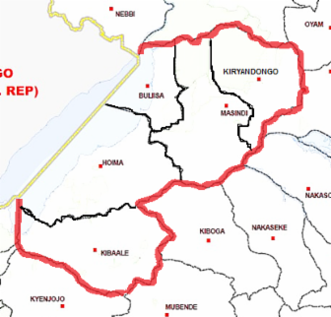

Key
One dot for coffee represents 1,000,000 Hectares of land
One dot for pineapple represents 10,000 Hectares of land

Advantages of dot maps
- Easy to draw when figures are accurate
- Gives a good visual impression when neatly drawn
- Easy to interpret when the scale is clearly shown
- Several items can be represented using different colors. Eg pineapple production can be shown yellow, coffee, red and cotton brown
Disadvantages of dot maps
- Difficult to maintain uniform dots.
- Difficult to determine value of each dot 9 scale) when values are two large
- There is over crowding of dots when vales are too large
- Difficulties in interpretation when values are too large
- Requires a lot of time to plot dots of different items
- It occupies a lot of space is the base maps is large.

FLOW MAPS/FLOW LINE MAPS
This is a form of statistical representation that is mainly concerned with changes in location. The purpose of this map is to represent movement from place to place. It shows such things as;
- The movement of goods from an area of production to market or export points
- The movement of vehicles along a particular route
- The paths of cyclones
- The migratory movements of people or livestock
- The type or frequency of traffic by railway, road water or air

Construction procedure
- Use a base map which shows the route network
- Choose a suitable scale. Consider the highest and the lowest value. This helps to determine the width of each line. This is done by dividing the figures with a constant value like 1000, 10,000, 100,000 etc
- Using a base Map, draw lines to the direction of flow. The size or width each line depends on the values obtained.
- One line can represent many items. Therefore the line should be shaded differently depending on the item being represented.
- Show the title, scale and the key of your map

Example
Table below show tonnage of goods from Uganda to selected countries in Africa
Countries | Tonnage
Kenya | 35,000
Tanzania | 51,000
Rwanda | 6,000

Kenya = 35,000 ÷ 100,000 = 0.4
Tanzania = 51,000 ÷ 100,000 = 0.5
Rwanda = 6,000 ÷ 100,000 = 0.06

Flow map showing tonnage of goods from Uganda to selected East Africa countries
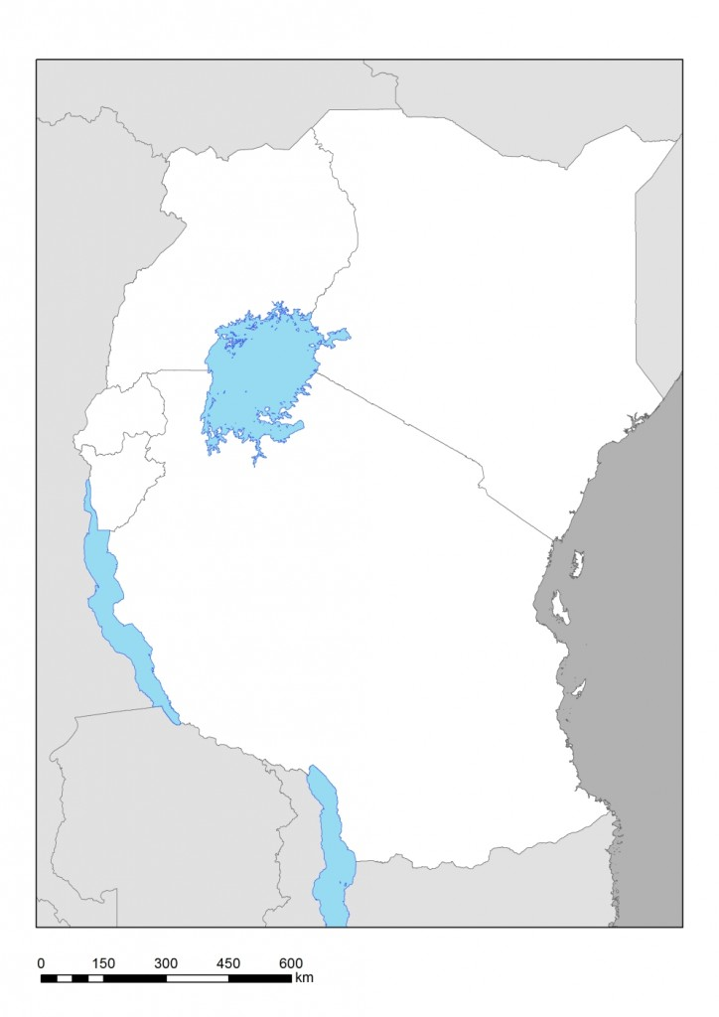
35,000
6000
51,000
Rwanda
N
Tanzania
Kenya
Uganda

Study the table below showing tourist destinations to Africa from selected continents for 1970and 2000 in 000’s
Contents | 1970 | 2000
Europe | 82,000 | 93,400
North America | 56,000 | 64,000
South Africa | 2,400 | 3,000
Australia | 3,900 | 58,000
Asia | 5,500 | 6,000
- Using the base map provided, draw flow map to represent the above information
- State the merits and demerits of the method
- Calculate the percentage change in the total number of tourist for each continent between 1970 and 2000.
Solutions
1970 2000
Europe = 82,000 ÷ 100,000 = 0.8 93,400 ÷ 100,000 = 0.9
North America = 56,000 ÷ 100,000 = 0.5 64,000 ÷ 100,000 = 0.6
South America = 2,400 ÷ 100,000 = 0.02 3,000 ÷ 100,000 = 0.03
Australia = 3,900 ÷ 100,000 = 0.04 58,000 ÷ 100,000 = 0.6
Asia = 5,500 ÷ 100,000 = 0.05 6,000 ÷ 100,000 = 0.06
A flow map showing tourist destinations to Africa from selected continents for 1970 and 2000 in 000’s
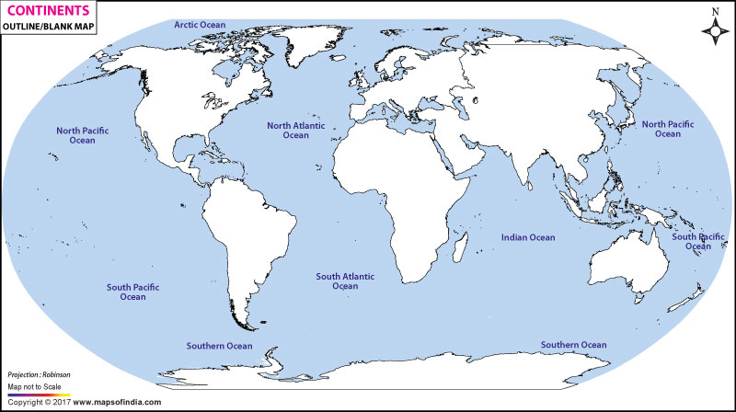
Europe
America
South
Asia
America
Africa
Australia
North

2000 1970

- Advantages of flow line maps
- They are easy to construct because they don’t involve a lot of calculations
- They give good visual impression when well-drawn
- They can show area where traffic congestion is a problem
- They can accommodate a variety of items
- They are easy to interpret when drawn of a good scale
Disadvantages of flow line maps
- Difficult to represent low volume in the map because it is difficult to draw lines
- Difficult to interpret when the scale is too small
- They have limited application
- Occupy a lot of space
- Need a lot of time

- Percentage change in the total number of tourist for each continent between 1970 and 2000.
Europe = 93,400 – 82,000 x 100%
82,000
= 14%

North America = 64,000 – 56,000 x 100%
56,000
= 14%

South America = 3,000 – 2,400 x 100%
2,400
= 58%

Australia = 58,000 – 3,900 x 100%
3,900
= 14%

Asia = 6,000 – 5,500 x 100%
5,500
= 09%

CHLOROPLETH MAPS/SHADING MAPS
This is a method where information is represented using a shading system on the map.
They are drawn to represented average values such as:

- Population densities
- Crop yield
- Livestock densities

This type of representation is system based on administration and natural boundaries. E.g. country, district, county, villages, geographical or physical boundaries.
The intensity of shading varies with the density of the items. As the density increases in each administrative area so does the shading.

Construction procedures
- Obtain relevant and suitable base map
- Calculate the average densities for each statistical unit. This is done by dividing the each unit by the land area of location.
- Choose a suitable class interval. Avoid too few or too many classes e.g 1-10, 11-20 21-30 etc. This act as scale.
- Choose a suitable type of density shading or coloring. Shading should be line shading either vertically, horizontally or diagonally. Shading should show a progressive increase in density
- Areas with high densities have lines shaded close to each other and areas with low densities have sparse lines.

Example; population densities of selected districts in mid-western Uganda
District | Population | Land area | Density
Kibaale | 1,802,000 | 3,000 | 600.7
Hoima | 2,802,000 | 2,000 | 1,401
Masindi | 1,897,000 | 4,000 | 474.25
Buliisa | 1,121,000 | 1,000 | 1,121
Solution
500 – 900
1000 – 1400
1500 – 1900
2000 – 2400
2500 – 3000
3500 – 4000
4,400 – 5000
Shading Map showing population densities of selected districts in mid-western Uganda
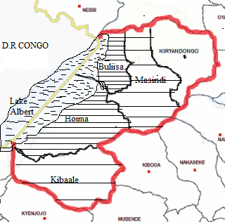
Study the table below showing countries of West Africa by area population and population densities in 2017
Country | Area(KM²) | Total population | Population density
Algeria | 2,381,741 | 41,320,000 | 17.3
Nigeria | 923,763 | 190,900,000 | 206.7
Ghana | 238,535 | 28,830,000 | 120.7
Ivory cost | 322,463 | 24,290,000 | 75.3
Liberia | 111,369 | 4,732,00 | 42.5
Mali | 1,240,000 | 18,540,000 | 15
Mauritania | 1,030,700 | 4,420,000 | 4.3
Niger | 1,268,000 | 21,480,000 | 17
Burkina Faso | 274,200 | 19,190,000 | 70
- raw Shading Map to showing population densities of selected counties of west Africa in the table above
- Outline merits and demerits of using chloropleth method

Shading Map showing population densities of selected West African countries in 2017

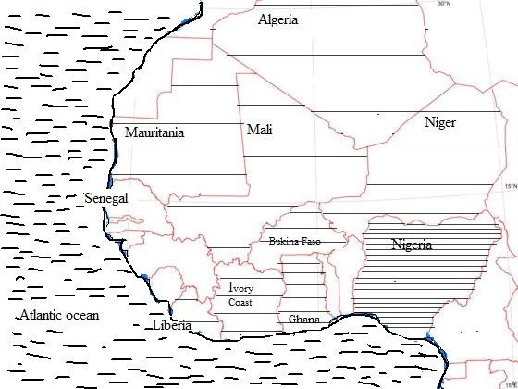

Advantages if chlopleth maps
- They are easy to construct
- They are suitable for presenting average values
- They good visual impression

Disadvantage of chloropleth maps
- Wrong impression that density changes suddenly at administration boundary
- Variations within one statistical unit are not shown
- Occupy large space
- Require a lot of time to construct

ISOLINE MAPS
This is the one in which lines are drawn to join places or points that have the same value of a certain phenomenon.
Isoline maps help the reader to recognise patterns and relationships between the geography of an area and data that might have been collected on the ground, such as air temperature.
Other terms used for these methods are;
- Isopleths
- Isorithms
- Isometric lines

Isolines are mainly used to represent elements involved in climatic study such as;
- Rainfall by isohyets
- Temperature by isobars
- Pressure by isobars
- Degree of cloudiness by isoreth

Apart from mapping climatic data, isolines can also be used to show areas of equal;
- Transport costs by isodapanes
- Ocean depth by isobaths
- Salinity by isohalines
- Height by contours

Construction procedures
- Study the statistics given on the base map
- Choose a suitable interval e.g 20,40,60,80,100 etc
- Using smooth line, join the interval chosen. Lines should not cross each other
- Space between isolines may be shaded to give a greater visual impact
- Complete the map with title and key

An outline map of Greater London showing the maximum temperature (in °C) recorded on a given day in the summer.

Isolines map of Greater London showing the maximum temperature (in °C) recorded on a given day in the summer (at 1°C intervals).

This map can be further simplified by removing the actual data points and only showing the isolines with their labels.

Example 2
Study the figure below showing point data of relief for a region A and answer questions that follow.
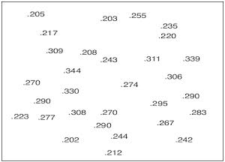
Solution
Create new layer you will draw contours in; star by drawing a new interval box to contain the isoline (contour) map itself.
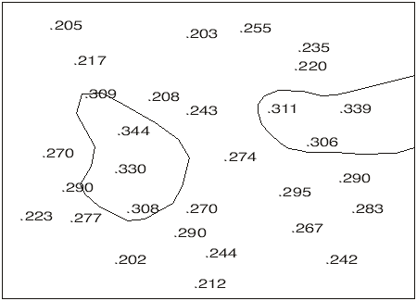
A contour is drawn to represent the 300M level. Since there are two patches of higher land there are two separate contours. Another contour is added 250M level.
The final contour map is seen below
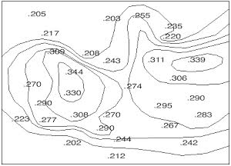
Advantages of isoline maps
- Values can be obtained from any point
- Isoline maps show gradual changes in value from one point to another
- Easy to interprets
- Easy to draw

Disadvantages of isoline maps
- They are tedious to construct
- Interpolation of values may be s

